**Streaming Camera Video using VLC player.**

In the first method, we are going to stream the camera video using [VLC player](https://www.videolan.org/vlc/index.html). To do this, first open the terminal window and type the following command to install VLC on your Raspberry Pi.

“Sudo apt-get install vlc”

After the successful installation, you can stream your camera video using the following command

 “raspivid -o – -t 0 -n | cvlc -vvv stream:///dev/stdin –sout ‘#rtp{sdp=rtsp://:8554/}’ :demux=h264”

To obtain the output of the video streamed by the camera, connect your PC or phone to the same Wi-Fi network on which Raspberry Pi is connected. Next open the VCL player, then go on stream menu and paste the url.

rtsp://ip address of your pi:8554/

**OPTIONAL :**

Now, open the text editor and put the following code in it

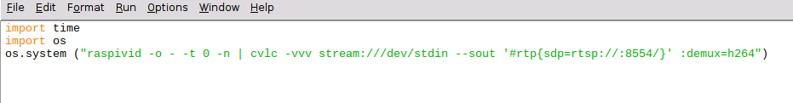

And save it as cam.py and whenever you want to live stream a video, run this program.

**Streaming Video Using Motion**

Open the terminal and run the following command to install motion  “sudo apt-get install motion”

Then setup setting to run the camera server continuously on background

“sudo nano /etc/default/motion”

 start_motion_daemon=yes

Then make some changes in motion config as described below (Refer Fig 5).

Run this command

“sudo nano /etc/motion/motion.conf”

Do these changes according to your need

Stream_port=8081

Stream quality 50 # set the quality according to your need

# Allow motion to run the daemon we’ve set earlier  
daemon on

# set the framerate of the stream (100 for higher quality)  
framerate 100

# set the width and height of your video  
width 640  
height 480

# control de port 8080 by default  
webcontrol_port 8080

# careful! don’t set the stream_port just like the webcontrol port

When you done with the above setting, save and exit the config file using key “CTRL + X”. Then hit the Y key and then press enter.

To start camera video streaming, open the terminal and run this command

“sudo service motion start”

“Sudo motion”

Now, connect your PC and Raspberry Pi on the same network. After that open any web browser and type the following url

https:// ip address of your raspberry pi:8081

Now you can get the camera video streaming on your web browser.

**Editing rc.local**

On your Pi, edit the file /etc/rc.local using the editor of your choice. You must edit it with root permissions:

sudo nano /etc/rc.local

Add commands to execute the python program, preferably using absolute referencing of the file location (complete file path are preferred). Be sure to leave the line **exit 0** at the end, then save the file and exit. In nano, to exit, type Ctrl-x, and then Y.

**[Edit RC Local File Configure Run a Program On Your Raspberry Pi At Startup](https://amzn.to/2rPNhER)**

If your program runs continuously (runs an infinite loop) or is likely not to exit, you must be sure to fork the process by adding an ampersand (“&”) to the end of the command, like:

sudo python /home/pi/sample.py &

The Pi will run this program at bootup, and before other services are started.  If you don’t include the ampersand and if your program runs continuously, the Pi will not complete its boot process. The ampersand allows the command to run in a separate process and continue booting with the main process running.

Now reboot the Pi to test it:

sudo reboot